Demo/POC Workflow
POS/TOMS Section

Feb 2026

Contents
Introduction 2
1. Objective 2
2. Process Inputs 2
3. Expected Outputs 2
4. Process / Steps to Be Followed (AS-IS) 4
5. Parties Involved & Accountability 6
6. Exceptions & Escalations 6
7. Communication Procedures 6
8. Risks / Pain Points 6
9. Workflow Diagram 6
9.1 POS development process flow chart 6
9.2 Demo/POC Process – Process Step Description 8

Introduction

Objective

- To effectively demonstrate the capabilities and business value of POS devices and TOMS monitoring solutions to customers. This involves demonstrating their functionalities and performance to ensure technical feasibility and alignment with customer requirements

Process Inputs
The POC/Demo process initiated by:
- Customer Request: Customer requests product demonstration
- Sales Team Initiation: When the sales teams search for new business opportunity, for new Proposal submission stage, new market expansion.
- Product Update: When there is a new POS mode introduction, new POS hardware type, new OS or firmware version, newly developed functionality, and major TOMS monitoring upgrade.
Required Documents/Systems: Customer Requirement Document (if available), Product Specification Sheet, Demo Script/Presentation, Test POS Devices, Integration Simulation Setup, TOMS Monitoring Dashboard (Demo Instance), Sample Transaction Data, and Network Connectivity.

Expected Outputs

- The deliverables at the end of the process include a Completed Demo/POC Report, a Customer Feedback Summary, a Gap Analysis (if needed), and a Technical Feasibility Confirmation.

Process / Steps to Be Followed (AS-IS)
No | Activity | Who does it | How It Is Done (Current / AS-IS) | Notes / Observations | Time Duration
1. | Opportunity Identification | Sales Team /Customer | Request received or sales initiative | In order to move forward to the next preparation step | 3 days
2. | Requirement Gathering | Sales/ POS/TOMS Section | Collect customer business & technical requirements | Important to know the customers need and compete in the market well | 1 week
3. | Scope Definition | POS/TOMS Section | Define demo scope (hardware, software, and monitoring) | To know the demo scope to present well | 1 day
4. | Setup Integration Simulation | POS/TOMS Section | Configure POS devices & demo integration simulation server | To demonstrate the functionality well | 1 day
5. | POS Hardware and Software Demonstration | POS/TOMS Section | Show Hardware parts, Demonstrate UI, transaction flow, and demonstrate API integration capability | Present the hardware, software and API integration | 1 day
6. | TOMS Monitoring Demo | POS/TOMS Section | Show live monitoring dashboard | To make them understand about TOMS environment | Half day
7. | Q&A Session | All Teams | Address customer queries | To clarify the customer doubt | 30 min
8. | Feedback Documentation | Sales/ POS/TOMS Section | Document customer suggestions, concerns, and observations. | Useful for SWOT analysis and improvement planning. | 1hr
9. | Internal Review | Sales/ POS/TOMS Section | Evaluate feasibility & customization need | To make analysis | 1 day
10. | Final Reporting | Sales Team | Prepare and submit Demo/POC summary report to management. | To make the final decision | 2 day

Parties Involved & Accountability
- Task Owner / Responsible Department: POS/TOMS Section
- Supporting Team Members: Software Engineers, and Sales Team
- Vendors / External Parties: Newland Vendors

Exceptions & Escalations

- Escalations: The POS/TOMS Manager will directly escalate issues to Newland vendors, and Sales team to resolve critical problems effectively and efficiently.
- Situations where the normal process cannot proceed due to the POC environment not being ready and customer requirements being outside the project scope

Communication Procedures
- Internal Communication: Daily and weekly team discussions on progress and challenges through WhatsApp, Teams and Orally.
- Escalations Communication: Immediate notification via Teams, email and WhatsApp for critical issues, with direct communication to Newland vendors for resolution.
- Frequency of Updates/Reports: Biweekly updates on project status but mostly in daily basis.

Risks / Pain Points
- Network instability during live demo
- Vendor delays in customization and implementation may affect software deployment schedules.
- Lack of clear ownership of the project can lead to confusion and inefficiencies.

Workflow Diagram

9.1 POS development process flow chart

S/N | INPUT | PROCESS | OUTPUT | RESPONSIBLE
1 | Start | 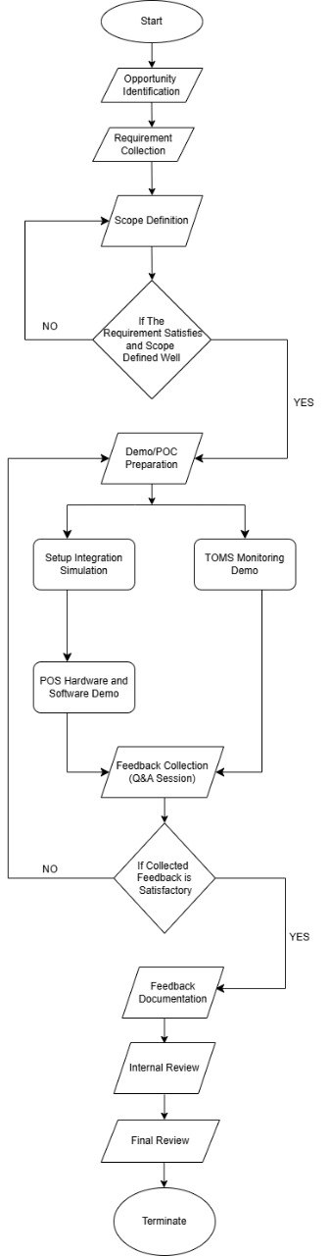 | Demo/POC Initiated | Sales/POS/TOMS Section
2 | Lead / Market input |  | Identified Opportunity | Sales Team
3 | Identified Opportunity |  | Collected Requirements | Sales Team
4 | Collected Requirements |  | Defined Scope / Proposal Outline | POS/TOMS Section
5 | Defined Scope |  | Yes → Proceed / No → Loop back to Scope Definition | POS/TOMS Section
6 | Approved Scope |  | Prepared Demo / POC Environment | POS/TOMS Section
7 | Prepared Demo/POC |  | Configured Integration Simulation | POS/TOMS Section
8 | Prepared Demo/POC |  | TOMS Monitoring Demo Ready | Vendor (Newland)
9 | Simulation + TOMs Demo |  | POS Hardware & Software Demo Performed | POS/TOMS Section
10 | Demos Completed |  | Collected Feedback / Q&A Notes | POS/TOMS Section
11 | Feedback Notes |  | Yes → Proceed / No → Loop back to Demo/POC Preparation | Vendor (Newland)
12 | Satisfactory Feedback |  | Documented Feedback Summary | POS/TOMS Section/ Vendor
13 | Documented Feedback |  | Internally Reviewed Feedback & Recommendations | POS/TOMS Section
14 | Internal Review Results |  | Final Review Decision / Closure Report | POS/TOMS Section/ Sales
15 | Final Review Completed |  | Project / Opportunity Closure | POS/TOMS Section/ Sales

9.2 Demo/POC Process – Process Step Description
FLW | Process Step Description
1. | Start
2. | Identify business opportunity through leads, market analysis, client inquiries, or internal proposals. Document the potential project/opportunity.
3. | Collect detailed requirements from the prospective client (functional, technical, business needs, expected outcomes, constraints).
4. | Define the project scope clearly, including deliverables, boundaries, assumptions, timeline, and high-level resources required. Prepare initial proposal outline if applicable.
5. | Evaluate whether the collected requirements are well understood and the scope is clearly and satisfactorily defined. If NO, return to step 4 (or step 3 if more clarification is needed). If YES, proceed.
6. | Prepare the Demo / Proof of Concept (POC) environment, including necessary configurations, test data, hardware/software setup, and scenario scripts.
7. | Set up integration simulation to demonstrate how the proposed solution integrates with the client’s existing systems or processes.
8. | Prepare and validate the TOMs Monitoring demonstration component (if part of the proposed solution).
9. | Conduct live demonstration of POS hardware and software functionalities as per the defined scope and scenarios.
10. | Hold feedback collection session (Q&A) with the client immediately after the demo to capture impressions, concerns, suggestions, and required adjustments.
11. | Assess whether the collected feedback is satisfactory and the client is convinced / interested to move forward. If NO, revise demo/POC based on feedback and return to step 6. If YES, proceed.
12. | Document all feedback received, including positive points, improvement areas, and any commitments or next steps agreed with the client.
13. | Conduct internal review of the feedback, demo outcomes, and opportunity viability. Prepare recommendations (proceed, revise, or drop).
14. | Perform final review with top management / decision makers to approve next steps (e.g., full project initiation, contract negotiation, or closure).
15. | Terminate. Opportunity evaluation and demo/POC phase completed.

